- April's upside surprise for UK inflation undermined financial markets' confidence in an August rate cut. But the Bank of England's favoured measure showed a further cooling in underlying services inflation and given that policy is still comfortably in restrictive territory, we think another rate cut in August remains likely.
- The symbolism of this week's UK-EU trade deal was far more important than the actual content, in our view. The deal was largely an agreement to negotiate a deeper UK-EU relationship over the coming years and won't yield immediate benefits, so doesn't affect our forecasts.
April has become the key month for inflation data, with a variety of regulated and inflation-linked prices, such as phone contracts, changing that month. Given that many of these prices only change once-a-year, April's outturn has outsized importance for the following 11 months.
This year's increases were larger than we and most other forecasters had anticipated. Coming alongside a big rise in the energy price cap and a spike in air fares caused by the timing of Easter, this meant that CPI inflation jumped to 3.5% in April, from 2.6% in March. Financial markets reacted hawkishly. Prior to the inflation data, market pricing implied a 62% chance of a 25bps rate cut in August, but this subsequently dropped to just 46%.
But the inflation release wasn't all bad news. The Bank of England's favoured measure of underlying services inflation, which excludes the impact of indexed and volatile components, edged downwards (Chart 1). Core goods inflation softened, while there was no obvious immediate impact from firms trying to pass on the increases in employers' national insurance contributions and the national living wage.
We still think an August rate cut is likely, given the policy rate is still comfortably in restrictive territory and there are concerns about the durability of demand. Furthermore, in a speech this week, Huw Pill, who opposed May's rate cut, characterised his vote for no change as a skip, rather than a signal that he wanted to stop loosening policy entirely.
Chart 1: CPI inflation rose sharply but the BoE's favoured measure of underlying services inflation cooled
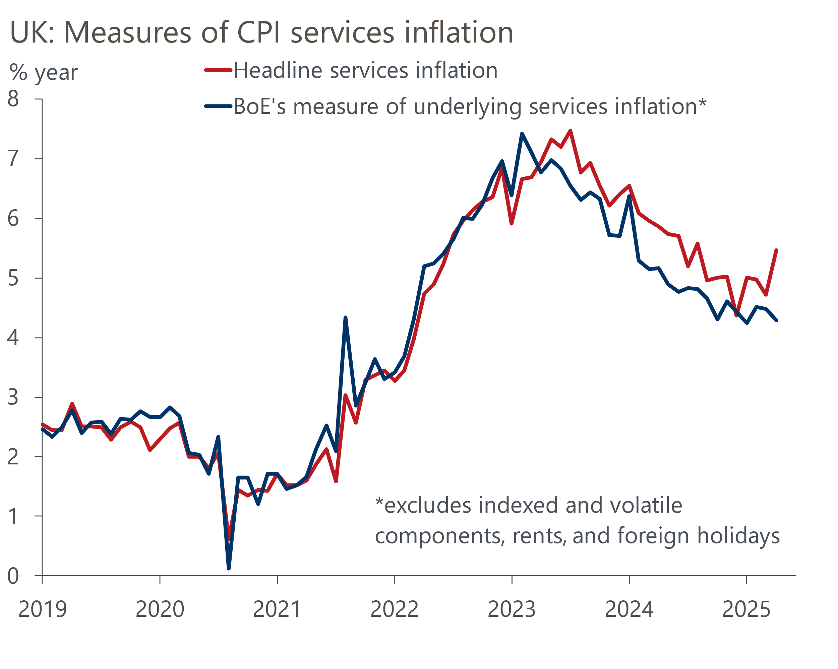
Source: Oxford Economics calculations using data from Haver Analytics

The week's activity data was mixed. May's flash S&P Global survey reported a modest improvement in the composite PMI to 49.4 from 48.5 in April, but this still implied that activity was falling. However, the relationship between the survey and official output data has been particularly poor recently, and we think the survey is picking up the general corporate mood rather than genuine changes in activity (Chart 2).
Chart 2: The composite PMI has been a poor predictor of changes in GDP
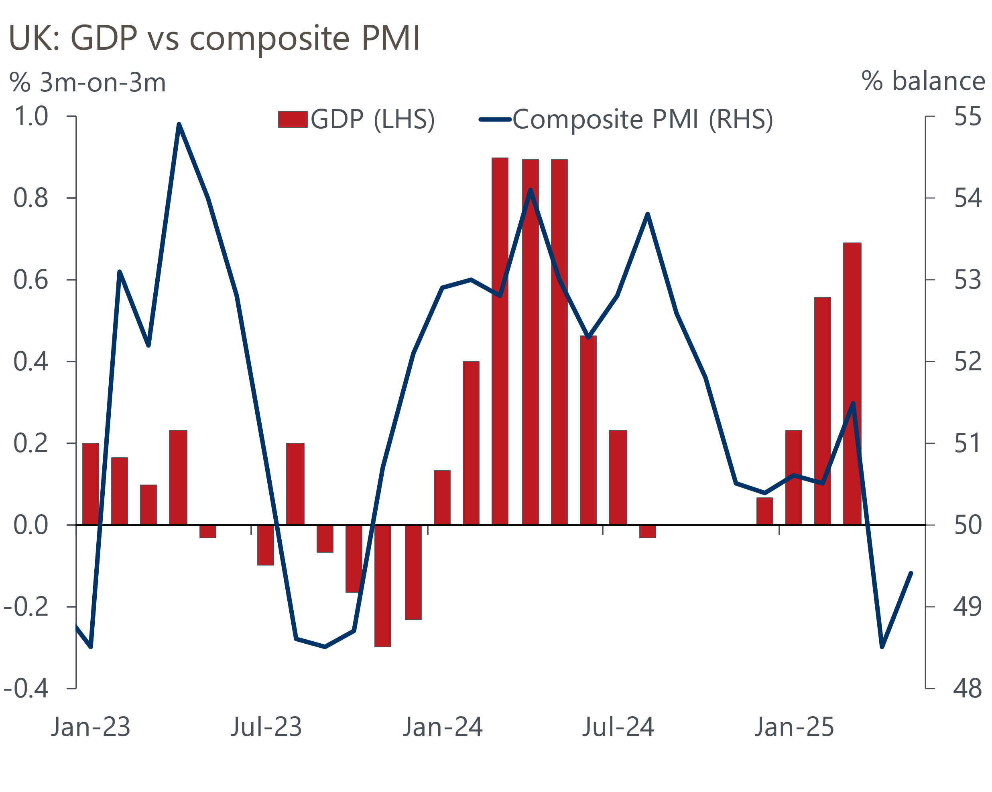
Sources: ONS, S&P Global
Retail sales surged by 1.2% month-on-month in April, building on a very strong Q1. But we're very sceptical about the sudden retail renaissance. In Q1, there was a wide disparity between the strength of retail sales and output data for the non-retail parts of consumer-facing services and another very weak reading for consumer spending. The lack of consistency across the various ONS series and question marks over what the survey data are telling us makes it very hard to judge the underlying strength of the economy. On balance, we think GDP growth will remain in positive territory in Q2 but come in softer than Q1.
This week also saw the first post-Brexit summit between the UK and EU. To mark the occasion, the two sides announced a security and defence pact and said they had agreed to work towards a series of other agreements covering sanitary and phytosanitary (SPS), youth mobility, and a combined emissions trading system. As with the UK's recent trade deals with the US and India, much of the detail is still to be negotiated and the timeframe for any changes to be agreed and implemented is vague.
In macroeconomic terms, establishing a common SPS area would be the most significant development. This would require the UK to remain aligned with EU regulations for agrifood products, and in return the EU would remove some routine checks on animal and plant products entirely and reduce others. This would allow agrifood goods to be exported and imported more quickly and at lower cost. But food exports to the EU account for only 4% of UK goods exports and just 0.6% of UK GDP, so the macroeconomic impact would be limited. Bigger economic gains to substantially reduce the damage to growth prospects caused by Brexit will require much closer integration, either via membership of the single market or a customs union. The current political environment means both options look unlikely.
Given the SPS agreement is currently only an aspiration, not a concrete outcome, we would be very surprised if the Office for Budget Responsibility incorporates any impact in its next set of forecasts. There's still a long way to go until the Budget, but as things stand it looks almost certain that the Chancellor's slim headroom against the fiscal rules will be more than eliminated. The improvement in the current budget deficit was disappointingly small in April, and the OBR will likely judge there is more structural weakness in the public finances than they previously thought. The official forecaster will also come under pressure to cut its optimistic potential output forecasts in light of recent US trade policy announcements, while higher gilt yields and market expectations for Bank Rate will push up debt servicing costs.
Given the Prime Minister's admission that he is reconsidering cutting winter fuel payments for pensioners, and the likelihood that defence spending will need to rise again, tax rises look an ever more likely prospect.

The week ahead
There are no major data releases next week.

Key forecasts
Table 1: UK forecast overview
(Annual percentage changes unless specified)
 | 2022 | 2023 | 2024 | 2025 | 2026 | 2027
GDP | 4.8 | 0.4 | 1.1 | 1.2 | 0.9 | 1.3
Private consumption | 7.3 | 0.5 | 0.6 | 1.0 | 1.2 | 1.3
Fixed investment | 5.1 | 0.3 | 1.5 | 2.0 | 0.6 | 1.6
Government consumption | 0.6 | 1.6 | 3.0 | 1.5 | 1.7 | 1.6
Exports of goods and services | 12.6 | -0.4 | -1.2 | 0.9 | -1.3 | 1.2
Imports of goods and services | 13.0 | -1.2 | 2.7 | 1.5 | -1.0 | 1.1
Industrial Production | -6.4 | -0.8 | -1.2 | 0.0 | -0.3 | 0.7
Consumer prices | 9.1 | 7.3 | 2.5 | 3.0 | 2.4 | 2.3
Unemployment rate (%) | 3.8 | 4.1 | 4.3 | 4.6 | 4.9 | 4.8
Current a/c balance (% of GDP) | -2.2 | -3.5 | -2.7 | -2.7 | -2.7 | -2.6
Government balance (% of GDP) | 4.3 | 5.2 | 5.1 | 4.4 | 3.6 | 2.9
Central bank policy rate (%, EOP) | 3.50 | 5.25 | 4.75 | 3.75 | 3.00 | 2.50
10yr govt. bond yield (%, EOP) | 3.67 | 3.54 | 4.57 | 4.48 | 3.95 | 3.45
Exchange rate (US$ per £, EOP) | 1.20 | 1.27 | 1.25 | 1.32 | 1.32 | 1.32
Exchange rate (euro per £, EOP) | 1.13 | 1.15 | 1.21 | 1.17 | 1.17 | 1.17
Source: Oxford Economics
Table 2: Quarterly forecasts for the UK
 | 2025 |  |  |  | 2026
 | Q1 | Q2 | Q3 | Q4 | Q1 | Q2 | Q3 | Q4
GDP (% year) | 1.3 | 1.0 | 1.1 | 1.2 | 0.7 | 0.8 | 0.9 | 1.0
CPI inflation (% year) | 2.8 | 3.1 | 3.3 | 2.9 | 2.7 | 2.1 | 2.3 | 2.4
Bank Rate (%, EOP) | 4.50 | 4.25 | 4.00 | 3.75 | 3.50 | 3.25 | 3.25 | 3.00
10yr gilt yield (%, EOP) | 4.70 | 4.70 | 4.59 | 4.48 | 4.36 | 4.23 | 4.10 | 3.95
US$ per £ (EOP) | 1.29 | 1.32 | 1.32 | 1.32 | 1.32 | 1.32 | 1.32 | 1.32
Euro per £ (EOP) | 1.20 | 1.17 | 1.17 | 1.17 | 1.17 | 1.17 | 1.17 | 1.17
Source: Oxford Economics

Latest Country Economic Forecast:
May 20, 2025

Recent publications

Data Insights
Retail sales surged again in April
PMI rebounds in May, but likely remains too downbeat
Public finances remain in a precarious state
Upside surprise for inflation unlikely to alter BoE's cutting cycle
Strong GDP growth in Q1 likely flatters the underlying conditions

Research Briefings
What the EU deal means for trade and growth
Employment nowcast suggests limited impact from NICs rise
MPC stays on its "gradual and careful" path
MPC Preview – tariffs could prompt a less cautious approach
How will central banks react to the trade war?

Contacts

Oxford Economics' UK team
- Andrew Goodwin - Chief UK Economist - agoodwin@oxfordeconomics.com
- Edward Allenby - UK Economist - eallenby@oxfordeconomics.com

